**Instructions for Student Report Card Generation and Sender(SRCGS) Software users**

**Precautions and Requirements**

1. **Stable internet connection** of any ISP providing **1Mbps (At least) 5Mbps and above (Recommended)**
2. OS must be **Windows 7 ultimate service pack 3/Windows 8.1/Windows 10**
3. Sender/Teacher must have **Gmail(Google) account**.
4. **Gmail id and password** must be known.
5. **Genuine and accurate information** must be known and need to be provided during process.

Information Required

1. **School Name**
2. **Academic Year**
3. **Exam name**
4. **Number of Subjects**
5. **Marks per subject**
6. **Teachers name**
7. **Teachers email id and Password**
8. **Location of mark sheet in .csv format (just remember to browse)**
9. Sender/Teacher must have **mark sheet as excel file and saved as .csv (Comma delimited) file.**
10. Make sure that mark sheet **csv file is made according to the specified format**.
11. Make sure that **Parent’s/Student’s information like... mark, email id, etc... are all correct**.

**Step by Step Process**

1. Allow Less secure app access of Senders(Teachers) Gmail id which is going to use for sending report card to students/parents via. email

Google Search => allow unknown sources Gmail

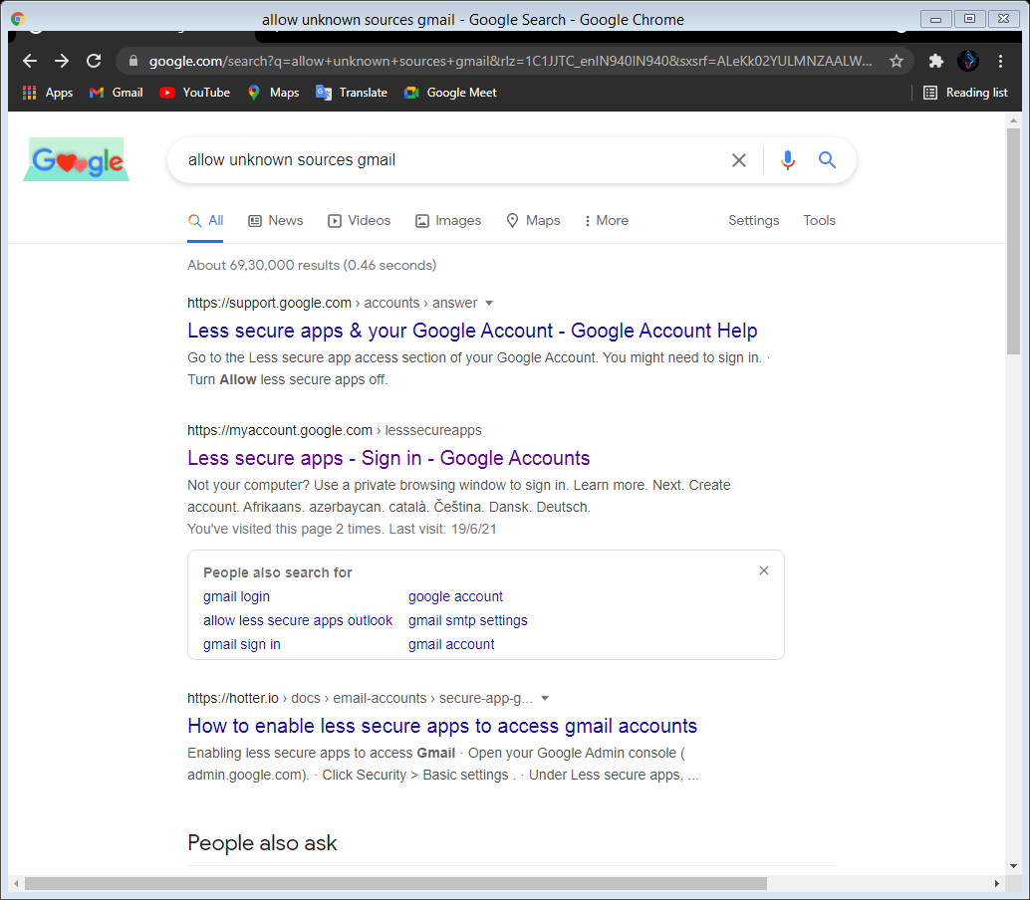

Click this option after search

ON the allow less secure app like below

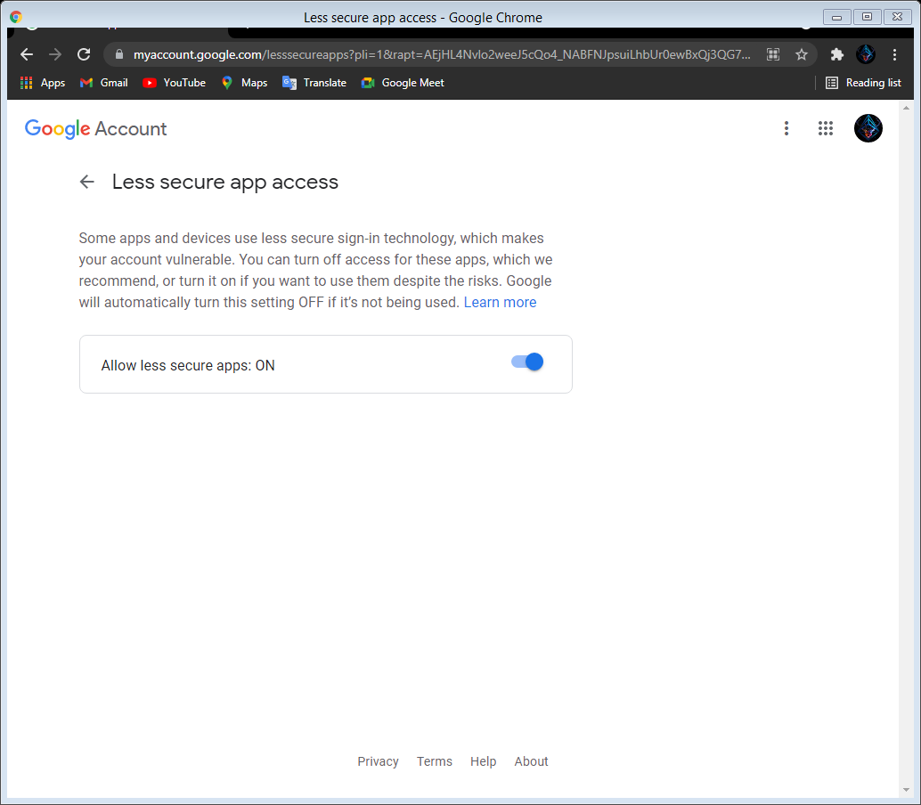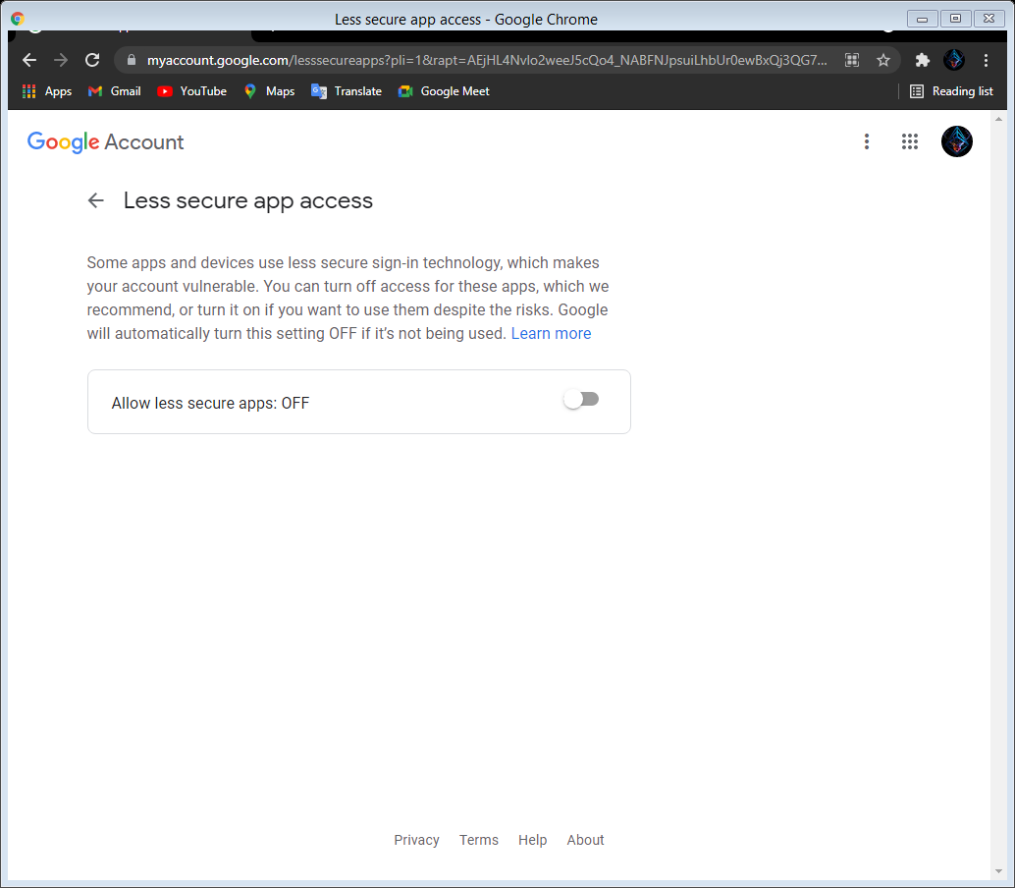

1. Make mark sheet in given format make sure that given details are correct and provided on right field mentioned below.

The below is a sample mark sheet in excel attributes can be of any name but column position must be followed as such like 1st column must be for roll no 2nd column must be for name, etc… number of subjects doesn’t matter at all but must be included in last columns just after email address of students/parents like here. Out of 100 is also not mandatory that’s can be added according to the examination conducted.

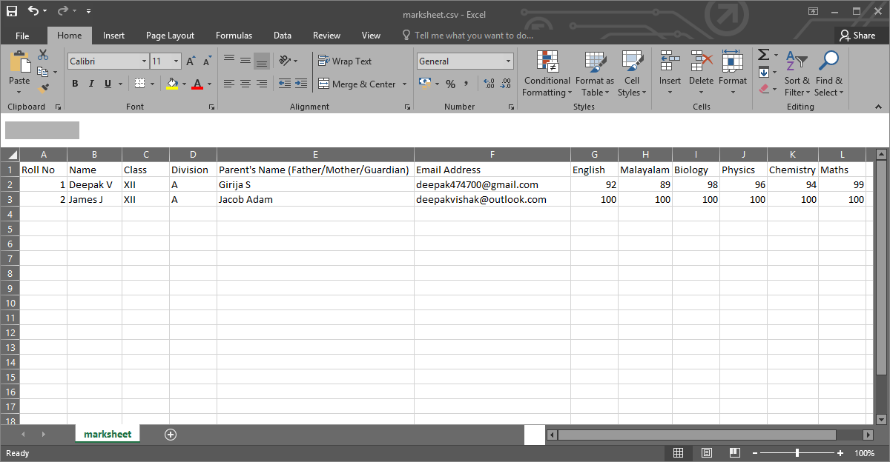

1. Save mark sheet as .csv (Comma delimited) file.

There are different .csv file formats available choose only .csv (Comma delimited) file as shown below.

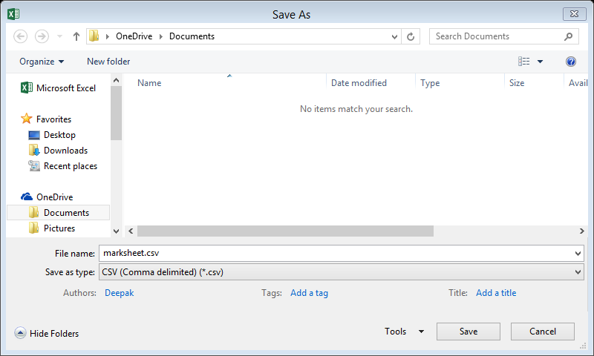

1. Give appropriate details to all text boxes provided Make sure not to make any mistakes which can lead to failure of the process.

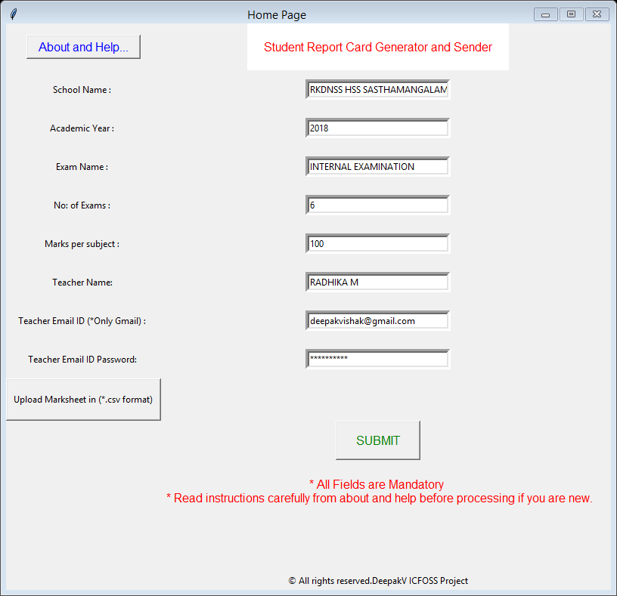

1. Click Upload mark sheet (*.csv format) button browse dialog box appears select intended mark sheet present as .csv file make sure its .csv (Comma delimited) before uploading.

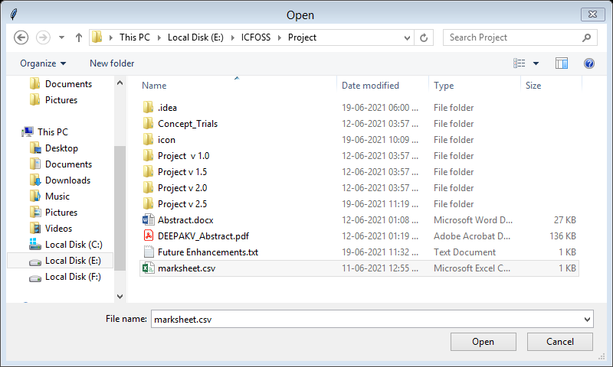

1. Go through the given details and confirm details if any mistakes correct it.
2. If all are perfect till this process, click submit button.

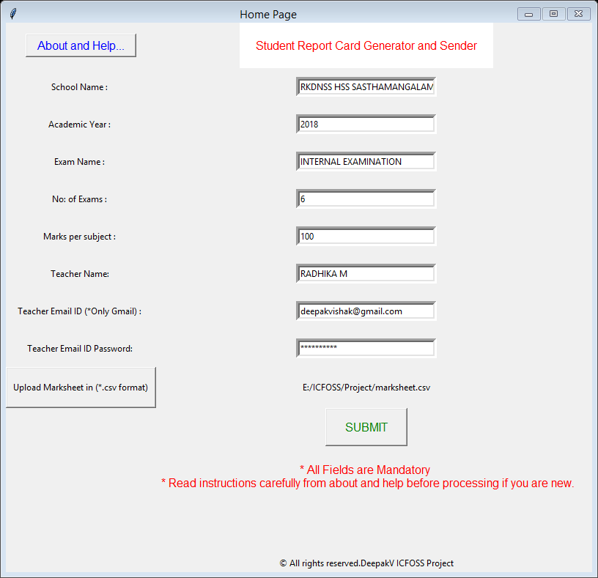

Click this button

1. 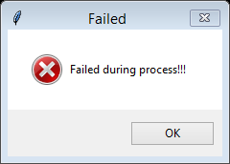Wait for few minutes if its success shows Email send successfully else failed during process.

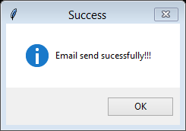

**For any Queries or Feedbacks:**

Contact developer for Queries: [Queries](mailto:deepak474700@gmail.com?subject=Query%20based%20on%20SRCGS%20Software)

Contact developer for Feedbacks: [Feedback](mailto:deepak474700@gmail.com?subject=Feedback%20on%20SRCGS%20Software)